1. Sunrisers Hyderabad (SRH) is a professional cricket team based in Hyderabad, India, and competes in the Indian Premier League (IPL).

2. The franchise was established in 2012 after the termination of the Deccan Chargers, another IPL team based in Hyderabad.

3. Sunrisers Hyderabad is owned by Kalanithi Maran of the SUN Group.

4. The team is currently coached by Brian Lara and captained by Aiden Markram.

5. Their primary home ground is the Rajiv Gandhi International Cricket Stadium in Hyderabad, with a capacity of 55,000.

6. Sunrisers Hyderabad made their IPL debut in 2013 and reached the playoffs in their first season, finishing fourth.

7. They won their maiden IPL title in the 2016 season, defeating the Royal Challengers Bangalore in the final.

8. Since 2016, the team has consistently qualified for the playoff stage of the tournament.

9. Sunrisers Hyderabad is known for having a strong bowling lineup and is often praised for its ability to defend low totals.

10. David Warner is the leading run scorer for the team, winning the Orange Cap three times, while Bhuvneshwar Kumar is the leading wicket-taker, winning the Purple Cap twice.

Note: The information provided is based on the knowledge cutoff of September 2021, and there may have been changes or updates since then.Home ground

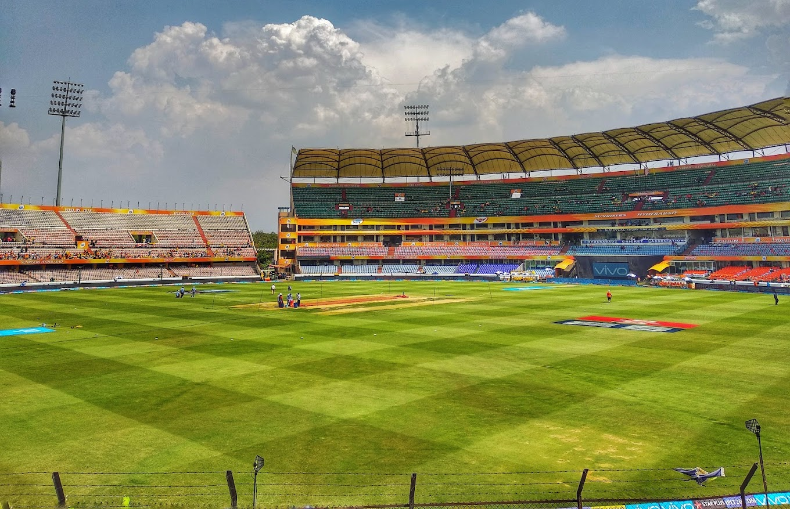1. The Rajiv Gandhi International Cricket Stadium, located in Hyderabad, Telangana, India, serves as the main cricket stadium for the Sunrisers Hyderabad team. Owned by the Hyderabad Cricket Association (HCA), it has a seating capacity of 55,000 spectators.

2. In 2015, the Dr. Y. S. Rajasekhara Reddy ACA–VDCA Cricket Stadium in Visakhapatnam, Andhra Pradesh, with a capacity of 40,000, was chosen as the secondary home ground for the Sunrisers Hyderabad. The team played their first three home games of that season at this venue.

3. During the 2017 season, as the defending champions, the Sunrisers Hyderabad hosted both the season opener and the final at their primary home ground, the Rajiv Gandhi International Cricket Stadium. The team had the privilege of selecting their home ground for hosting all their home games throughout the season.

Additional information: In the 2019 season, due to the unavailability of the M. A. Chidambaram Stadium in Chennai, the BCCI decided to shift the IPL final to the Rajiv Gandhi International Cricket Stadium. The Hyderabad Cricket Association received recognition for providing the best ground and pitch during the 2019 IPL

.Administration and support staff

|  |  |  |  |
| --- | --- | --- | --- |
| **Position** | | **Name** | |
| CEO | | K. Shanmugam[[48]](https://en.wikipedia.org/wiki/Sunrisers_Hyderabad#cite_note-48) | |
| General manager | | Srinath Bhashyam | |
| Team manager | | Vijay Kumar | |
| Head coach | | [Brian Lara](https://en.wikipedia.org/wiki/Brian_Lara) | |
| Assistant coach | | [Simon Helmot](https://en.wikipedia.org/wiki/Simon_Helmot)[[49]](https://en.wikipedia.org/wiki/Sunrisers_Hyderabad#cite_note-49) | |
| Batting coach | | [Hemang Badani](https://en.wikipedia.org/wiki/Hemang_Badani) | |
| Spin-bowling and strategic coach | | [Muttiah Muralitharan](https://en.wikipedia.org/wiki/Muttiah_Muralitharan) | |
| Fast bowling coach | | [Dale Steyn](https://en.wikipedia.org/wiki/Dale_Steyn) | |
| Fielding coach | | Ryan Cook | |
| Physio | | Theo Kapakoulakis | |
| Physical trainer | | [Mario Villavarayan](https://en.wikipedia.org/wiki/Mario_Villavarayan) | |
| **Source:**[[50]](https://en.wikipedia.org/wiki/Sunrisers_Hyderabad#cite_note-50) | | | |
|  |  |  |  |  |

Result summary

**By IPL season**

| **Year** | **Round** | **Position** | **Games played** | **Won** | **Lost** | **Tied** | **No result** | **Win %** |
| --- | --- | --- | --- | --- | --- | --- | --- | --- |
| [2013](https://en.wikipedia.org/wiki/2013_Indian_Premier_League) | Playoffs | 4th | 17 | 10 | 7 | 0 | 0 | 58.82 |
| [2014](https://en.wikipedia.org/wiki/2014_Indian_Premier_League) | League stage | 6th | 14 | 6 | 8 | 0 | 0 | 42.86 |
| [2015](https://en.wikipedia.org/wiki/2015_Indian_Premier_League) | League stage | 6th | 14 | 7 | 7 | 0 | 0 | 50.00 |
| [2016](https://en.wikipedia.org/wiki/2016_Indian_Premier_League) | **Champions** | 1st | 17 | 11 | 6 | 0 | 0 | 64.70 |
| [2017](https://en.wikipedia.org/wiki/2017_Indian_Premier_League) | Playoffs | 4th | 15 | 8 | 6 | 0 | 1 | 57.14 |
| [2018](https://en.wikipedia.org/wiki/2018_Indian_Premier_League) | **Runners-up** | 2nd | 17 | 10 | 7 | 0 | 0 | 58.82 |
| [2019](https://en.wikipedia.org/wiki/2019_Indian_Premier_League) | Playoffs | 4th | 15 | 6 | 9 | 0 | 0 | 40.00 |
| [2020](https://en.wikipedia.org/wiki/2020_Indian_Premier_League) | Playoffs | 3rd | 16 | 8 | 8 | 0 | 0 | 50.00 |
| [2021](https://en.wikipedia.org/wiki/2021_Indian_Premier_League) | League stage | 8th | 14 | 3 | 11 | 0 | 0 | 21.42 |
| [2022](https://en.wikipedia.org/wiki/2022_Indian_Premier_League) | League stage | 8th | 14 | 6 | 8 | 0 | 0 | 42.86 |
| [2023](https://en.wikipedia.org/wiki/2023_Indian_Premier_League) | League stage | 10th | 14 | 4 | 10 | 0 | 0 | 36.36 |
| **Total** | **1 Title** | | 155 | 76 | 78 | 0 | 1 | 49.03 |

**By opposition**

| **Opposition** | **Seasons** | **Games played** | **Won** | **Lost** | **Tied** | **No result** | **Win ℅** |
| --- | --- | --- | --- | --- | --- | --- | --- |
| [Chennai Super Kings](https://en.wikipedia.org/wiki/Chennai_Super_Kings) | 2013–present | 19 | 5 | 14 | 0 | 0 | 26.31 |
| [Delhi Capitals](https://en.wikipedia.org/wiki/Delhi_Capitals) | 2013–present | 21 | 11 | 10 | 0 | 0 | 52.38 |
| [Gujarat Titan](https://en.wikipedia.org/wiki/Gujarat_Titans) | 2022–present | 2 | 1 | 1 | 0 | 0 | 50.00 |
| [Punjab Kings](https://en.wikipedia.org/wiki/Punjab_Kings) | 2013–present | 21 | 14 | 7 | 0 | 0 | 66.66 |
| [Kolkata Knight Riders](https://en.wikipedia.org/wiki/Kolkata_Knight_Riders) | 2013–present | 23 | 8 | 15 | 0 | 0 | 34.78 |
| [Lucknow Super Giants](https://en.wikipedia.org/wiki/Lucknow_Super_Giants) | 2022–present | 2 | 0 | 2 | 0 | 0 | 0.00 |
| [Mumbai Indians](https://en.wikipedia.org/wiki/Mumbai_Indians) | 2013–present | 19 | 9 | 10 | 0 | 0 | 47.36 |
| [Rajasthan Royals](https://en.wikipedia.org/wiki/Rajasthan_Royals) | 2013–present | 17 | 8 | 9 | 0 | 0 | 47.05 |
| [Royal Challengers Bangalore](https://en.wikipedia.org/wiki/Royal_Challengers_Bangalore) | 2013–present | 22 | 12 | 9 | 0 | 1 | 55.55 |
| [Gujarat Lions](https://en.wikipedia.org/wiki/Gujarat_Lions) | 2016–2017 | 5 | 5 | 0 | 0 | 0 | 100.00 |
| [Pune Warriors India](https://en.wikipedia.org/wiki/Pune_Warriors_India) | 2013 | 2 | 2 | 0 | 0 | 0 | 100.00 |
| [Rising Pune Supergiant](https://en.wikipedia.org/wiki/Rising_Pune_Supergiant) | 2016–2017 | 4 | 1 | 3 | 0 | 0 | 25.00 |
| **Total** | **2013-present** | **161** | **78** | **82** | **0** | **1** | **48.75** |

| Team now defunct |
| --- |

Rivalries

**Rivalry with RCB**

1. The rivalry between Royal Challengers Bangalore (RCB) and the Hyderabad franchises (Deccan Chargers and Sunrisers Hyderabad) has been intense, with the Hyderabad teams often dominating RCB. Deccan Chargers won 6 out of the 11 clashes between the two, and Sunrisers currently lead with 12 wins compared to RCB's 9.

2. The Hyderabad franchises have had a significant impact on RCB's campaigns in various seasons. Deccan Chargers and Sunrisers Hyderabad both won the IPL finals against RCB, with Deccan Chargers winning in 2009 and Sunrisers Hyderabad winning in 2016. In the 2020 season, a crucial clash between RCB and Sunrisers resulted in RCB being knocked out of the tournament.

3. Even in the midst of RCB's strong campaigns, the Hyderabad franchises have caused setbacks. In IPL 2021, despite RCB's strong performance, Sunrisers Hyderabad defeated them, resulting in RCB finishing third and having to play the eliminator match, which they eventually lost. Similarly, in the 2022 IPL season, RCB suffered a significant loss against Sunrisers Hyderabad, which put them under pressure due to their negative run rate throughout the tournament.